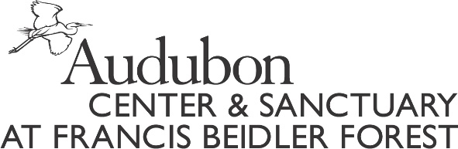

PLEASE FILL OUT THIS FORM COMPLETELY AND SUBMIT WITH THE REQUIRED ITEMS TO:
ATTN: Noel Williams
Francis Beidler Forest
336 Sanctuary Road
Harleyville, SC 29448
843-462-2150 FAX 843-462-2713
Email: nwilliams@audubon.org
SCHOLARSHIP APPLICATION DEADLINE IS MAY 1, 2020
____________________________________________________________________________
Summer Camp Scholarship Guidelines:
• Applicants are evaluated without regard to race, religion, natural origin, sex or physical ability.
• Funding is limited and scholarships are not guaranteed to all applicants.
• Scholarships may not be awarded two years in a row.
• Incomplete applications will not be reviewed.
• Scholarships will be awarded based on need and merit.

Summer Camp Scholarship Recipient Requirements:
□ Submit completed application
□ Submit letter of intent demonstrating passion for science and/or nature
□ Complete and submit follow-up report (attached) and/or letter after Summer Camp

Please fill out one form per child.
Scholarship Type:
□ Need
□ Merit

Name of Child_______________________________________________________________________ Birth date_____________/_____________/_______________________
Mailing Address______________________________________________________________________
City___________________________________________State______________________ZIP_________
Phone (_________________) __________________________________________________________
Family Email________________________________________________________________________
Rising Grade_________________________ School_________________________________________

How many children currently live in the household? ___________ Please list their ages______________

Do you currently have an Audubon Membership? □ Yes □ No

REQUIRED FAMILY INFORMATION
Father’s Name_______ ________________________________________________________________
Address (if different) ___________________________________________________________________
Mother’s Name _______________________________________________________________________
Address (if different) ___________________________________________________________________
Name of Legal Guardian (if not living with mother/father)_______________________________________

What do you hope your child will gain from this experience? ____________________________________________________________________________________________________________________________________________________________________________________________________________________________________________________________________________________________________________________________________________________________________________________________________________________________________________________________________________________________________________________________________________________________________________________________________________

Are there any extenuating circumstances, permanent or temporary, that make financial assistance necessary at this time? ____________________________________________________________________________________________________________________________________________________________________________________________________________________________________________________________________________________________________________________________________________________________________________________________________________________________________________________________________________________________________________________________________________________________________________________________________________________________________________________________________________________________________________________________________________________________________________________

Are other family members currently applying for assistance? □ Yes □ No
Has anyone in your family previously received financial assistance through our scholarship fund?
□ Yes □ No
If yes, when? ___________________________ How much was received? $______________________
Scholarship Amount you are requesting: ___________________Full __________________Partial

If you have any additional questions please call 843-462-2150 or email nwilliams@audubon.org

