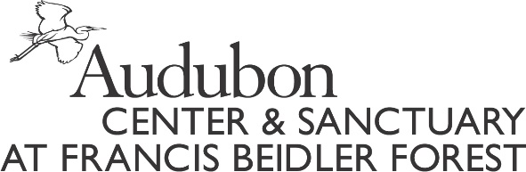

PLEASE FILL OUT THIS FORM COMPLETELY AND SUBMIT WITH THE REQUIRED ITEMS TO:
ATTN: Noel Williams
Francis Beidler Forest
336 Sanctuary Road
Harleyville, SC 29448
843-462-2150 FAX 843-462-2713
Email: nwilliams@audubon.org
SCHOLARSHIP APPLICATION DEADLINE IS MAY 1, 2018
*recipients will be notified via email by May 30
_____________________________________________________________________________________________
Summer Camp Scholarship Guidelines:
- Applicants are evaluated without regard to race, religion, natural origin, sex or physical ability.
- Funding is limited and scholarships are not guaranteed to all applicants.
- Incomplete applications will not be reviewed.
- Scholarships will be awarded based on need and merit.

Summer Camp Scholarship Recipient Requirements:
□ Submit completed application by May 1, 2018
□ Complete and submit follow-up report and/or letter after Summer Camp

Please fill out one form per child.
Scholarship Type:
□ Need
□ Merit

Name of Child________________________________________________________________ Birth date_____________/_____________/_______________________
Mailing Address______________________________________________________________
City_________________________________State______________________ZIP___________
Phone (_________________) ___________________________________________________
Additional Phone (__________________)__________________________________________
Family Email________________________________________________________________
Rising Grade_____________________ School______________________________________
How many children currently live in the household? ___________
Please list their ages___________________________________________________________

REQUIRED FAMILY INFORMATION
Father’s Name_______________________________________________________________
Address (if different) __________________________________________________________
Mother’s Name _______________________________________________________________
Address (if different) __________________________________________________________
Name of Legal Guardian (if not living with mother/father)______________________________

What do you hope your child will gain from this experience? ________________________________________________________________________________________________________________________________________________________________________________________________________________________________________________________________________________________________________________________________________________________________________________________________________________________________________________________________________________________________________________________________________________________________________________________________________________________________

Are there any extenuating circumstances, permanent or temporary, that make financial assistance necessary at this time? ____________________________________________________________________________________________________________________________________________________________________________________________________________________________________________________________________________________________________________________________________________________________________________________________________________________________________________________________________________________________________________________________________________________________________________________________________________________________________________________________________________________________________________________________________________________________________________________

Are other family members currently applying for assistance? □ Yes □ No
Has anyone in your family previously received financial assistance through our scholarship fund? □ Yes □ No

Scholarship Amount you are requesting: ______________Full ______________Partial

The Scholarships have been generously donated to us by Wild Birds Unlimited.
They were created to give as many kids as possible the opportunity to experience the benefits of our
Swamp Camp here at Francis Beidler Forest.
If you have any additional questions please call 843-462-2150 or email nwilliams@audubon.org

